***Sailasree Perumal***

***18113241@student.hindustanuniv.ac.in***

**INSTAGRAM REELS…**

[Instagram](https://www.instagram.com/?hl=en) :

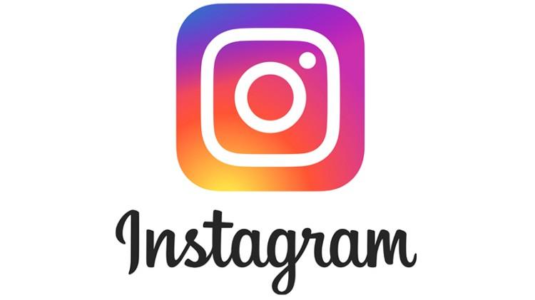

Ever since **INSTAGRAM** was launched by **Kevin Systrom** along with **Mike Krieger** in 2010 ,the app has been developing by adding several features ,one such latest feature they launched on *August 8th* this year is *INSTAGRAM REELS.*

***BACKGROUND…***

As we know,INDIAN GOVERNMENT has baned TIK TOK app with other 59 China based apps as part of digital war against China . Ever since the ban of popular apps including TIK TOK Indian app developers launched many apps in the lime light but none of those apps shined . Then came INSTAGRAM with it’s new feature ***REELS.***

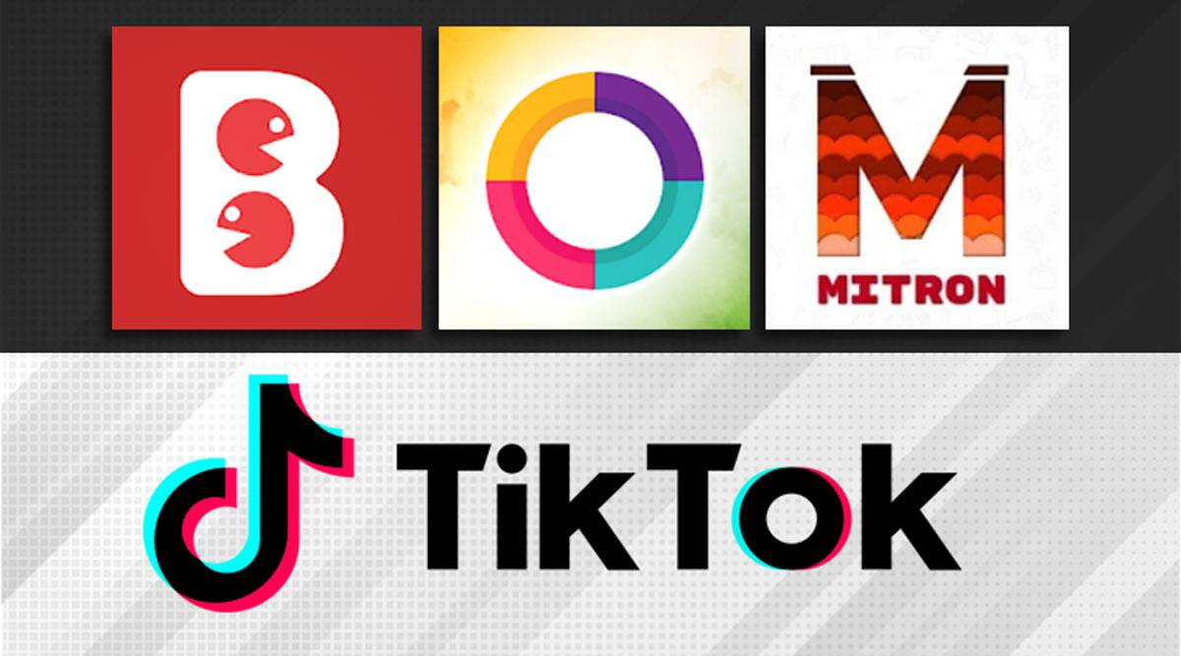

***FEATURES…***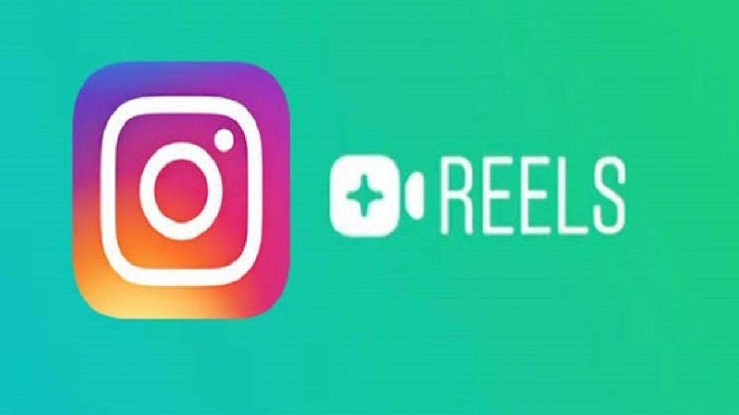

* Short videos with 15 sec runtime.
* Enables editing with AR and AUDIO FILES.
* Increases your reach ,if you have a public account.
* Sharing of videos is much simpler.

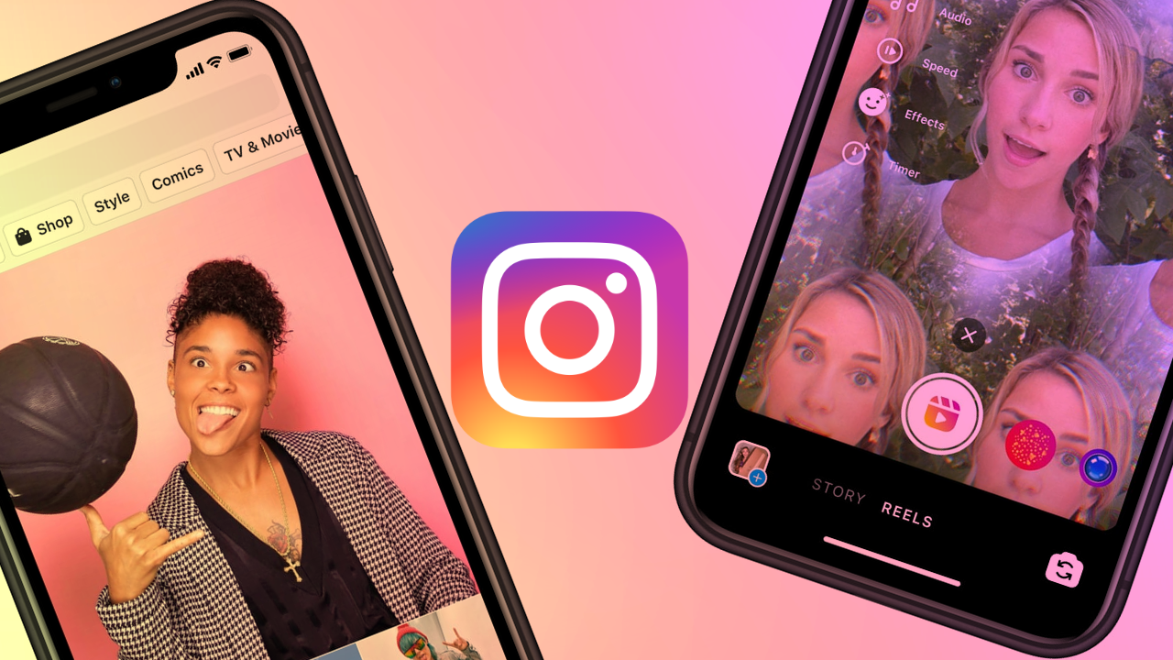

***TUTORIAL TO REACH REEL…***

You can find REELS in 2 places in your instagram account.

* INSTAGRAM came up with a special icon for REELS ,which showcases REELS collectively at a single palace.
* SEARCH EXPLORER also do showcase some trending REELS in one’s feed.

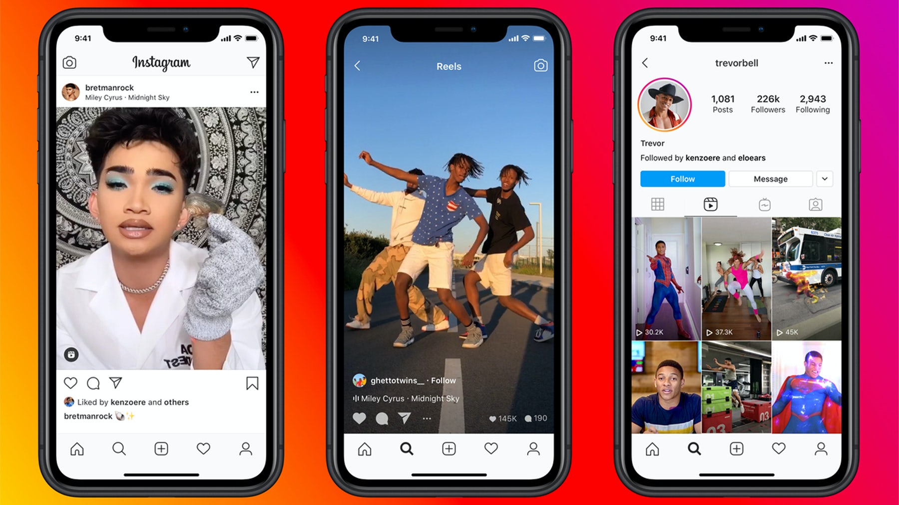

***SUMMARY…***

Many apps do come and go ,but very rare does an app create a strong impact on public.

TIK TOK has created a path for various social media influencers with it’s app.Let’s see to what extinct does Instagram REELS succeed to fill the gap…!!!